# Compass - High Deductible Health Plans (HDHP)

[Identifying an HDHP on a Member’s Account](#_Toc167271816)

[Determining if the Deductible Applies to the Maximum Out of Pocket (MOOP)](#_Toc167271817)

[How to Handle Member Reimbursement for Overpayments for HDHP Plans](#_Toc167271818)

[Related Documents](#_Toc167271819)

**Description:** How to identify a HDHP member and view accumulation details related to Maximum Out of Pocket (MOOP) or deductible. (The Deductible is the first stage of the plan where the member pays 100% of the negotiated cost of medication until deductible is met.)

|  |
| --- |
| Identifying an HDHP on a Member’s Account |

To ensure that member PHI is protected when discussing accumulators, any information relating to family-level accumulators should be limited to High-level information, such as:

* Yes or no answers to if family MOOP (Maximum Out Of Pocket), MAB (Maximum Allowable Benefit), and/or Deductible thresholds have been met.
* Total family MOOP, MAB, and Deductible thresholds, and current amounts accrued toward those thresholds.

Do **not**release any details for individual accumulators that contribute to the family-level accumulators other than the individual’s own.  Any details that make up the amount paid towards individual accumulators includes:

* Date of service
* Rx number
* MOOP
* MAB
* Deductible amount, etcetera

In some cases, the High Deductible Health Plans (HDHP) have a preventative drug list, which medications on that list would bypass deductible and apply to MOOP. Refer to [HDHP/HSA Preventive Drug List](https://www.caremark.com/portal/asset/preventive_dl.pdf).



Perform the following steps:

|  |  |  |
| --- | --- | --- |
| **Step** | **Action** | |
| **1** | Locate and click the **Accumulations** link from the **Quick Actions**panel on the Member Snapshot Landing Page.          **Result:** The **Accumulations**tab displays. | |
| **2** | Determine if the account has Member or Family accumulation benefits: | |
| **3** | Click the chevron next **Summary Details** and review the **Integrated Benefits** column. | |
| **If the Integrated Benefit column is…** | **Then…** |
| **No** | The member does not have integrated benefits and is not part of an HDHP. |
| **Yes, Met** or  **Yes, Not Met** | * The member has “integrated benefits” and is part of an HDHP; therefore, medical and prescription claims accumulate together to satisfy one deductible amount. * The Deductible is where member would pay 100% of the negotiated cost of medication until deductible is met.   **Note:**  Some High Deductible Plans have an [HDHP/HSA Preventive Drug List](https://www.caremark.com/portal/asset/preventive_dl.pdf) which bypasses the deductible and apply to MOOP. Review the CIF. |
| **4** | Determine the remaining amount needed to meet the deductible | |
| **If the deductible is…** | **Then…** |
| Met | The member has “integrated benefits” and they (Individual or Family) have met their deductible amount for the benefit year (count type displays as met) and the member is responsible for paying its co-insurance amount.  **Note:**  Some High Deductible Plans have a preventative drug list which will bypass the deductible and apply to MOOP. |
| Not Met | Refer to the “Remaining Amount” for the Individual or Family Account Type.  **Note:**  Some High Deductible Plans have a preventative drug list which will bypass the deductible and apply to MOOP. |
| **5** | Quote the Remaining Amount needed to satisfy the Deductible Limit Amount and review the CIF for deductible amounts.    **Example 1 (Non-Embedded):**   * Although this individual family member has not accrued any charges, the family has accumulated $759.05. * Everyone is not required to meet the deductible. * The family (not the individual) must pay an additional $1740.95 to meet the $2500 deductible amount. * Once this family deductible is met, the member will begin paying its co-insurance/copay amount.     **Example 2 (Embedded):**   * An individual is only required to meet the individual deductible before the plan benefits are paid. * All other individuals on the family plan must pay until their individual or family deductible has been satisfied.     **Example 3:**   * Member has a $500 embedded deductible and met it; member will pay co-insurances going forward. * Whereas the family members within the same plan must meet their own individual deductible of $500 not to exceed the family deductible of $1,500. | |

|  |
| --- |
| Determining if the Deductible Applies to the Maximum Out of Pocket (MOOP) |

From the Accumulations tab in Compass determine if the deductible applies to the MOOP.

**Note:**  Once the MOOP has been satisfied, the family is charged $0 for their prescriptions for the remainder of the benefit year.

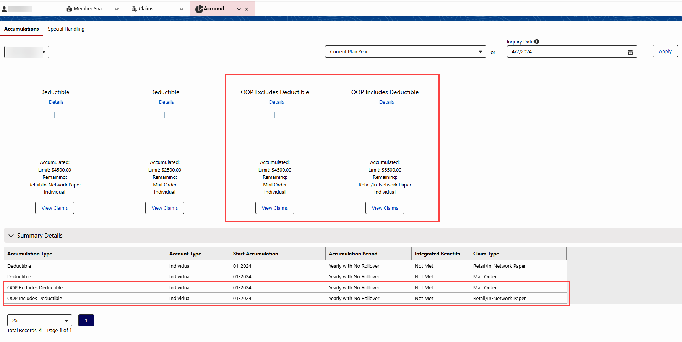

|  |  |
| --- | --- |
| **If the Account Class is…** | **Then the Deductible…** |
| MOOP-IN-DED | Deductible is included and applied in the MOOP amount.  **Note:**  Some High Deductible Plans have a preventative drug list which bypasses the deductible and applies to MOOP. |
| MOOP-EX-DED | Deductible is excluded (does not apply) to the amount needed to reach the MOOP amount. |

[Top of the Document](#_top)

|  |
| --- |
| How to Handle Member Reimbursement for Overpayments for HDHP Plans |

In cases of deductible or MOOP overpayments on HDHP plans, the medical plan will reimburse members.

**Note:** Pharmacy claims are real time and medical claims can have a delay depending on when they are submitted.

|  |  |  |
| --- | --- | --- |
| **Step** | **Action** | |
| **1** | From the Accumulationsscreen, click the **View Claims** buttonunder the **Deductible** or **OOP** column.Review the Pharmacy Claims and Pharmacy/Medical Adjustments and look for reversals.  **Note:**  Reversals are identified by a negative (-) sign next to the amount. | |
| **If a Reversal is…** | **Then…** |
| Present | Advise the member there has been a reversal from their medical plan and this may have brought them under their required balance for deductible or MOOP. This means that the balance has not been met at this time. |
| Not present | Proceed to the next step. |
| **2** | Verify that the Accumulated Amount is more than the Limit Amount for either the deductible or the OOP. Refer to [Compass - Viewing Accumulations (050010)](https://thesource.cvshealth.com/nuxeo/thesource/#!/view?docid=c4fb8a09-f22f-49cd-a22d-71930039f08c) **or** [CarelonRx Accumulators - Deductible, HDHP, MAB and MOOPs](https://thesource.cvshealth.com/nuxeo/thesource/#!/view?docid=12f37233-9a3a-4a6d-bd6f-a3ce23787904) (018947). | |
| **If…** | **Then…** |
| Yes | Proceed to the next step. |
| No | Advise the member that our records do not display an overpayment at this time, ask probing questions to determine why the member feels they are entitled to an overpayment.   * If possible, advise the member to contact their medical benefits or provider to ensure all claims have processed as expected.   **Example:** The member may have a medical claim that has not processed. |
| **3** | Review the CIF for plan-specific procedures.  **Note:** If the CIF directs to submit a Consumer Driven Health (CDH) Accumulations Support Task to correct accumulations to Deductible/MOOP/MAB, **do not** create a Participant CallBack Request Support task. The Account Manager verifies the accumulations and the member will be called back regarding resolution based on the phone number in the task. | |
| **4** | Advise the member to direct the inquiry to their medical plan.  **Note:** If the member disputes the accumulations, becomes escalated, or insists he/she will not pay for anymore prescriptions until reimbursed, submit Consumer Driven Health (CDH) Accumulations Support Task to correct accumulations to Deductible/MOOP/MAB. For assistance, refer to [Compass - Corrections to Deductible, MOOP, and MAB (CDH Accumulations Task) (061925)](https://thesource.cvshealth.com/nuxeo/thesource/#!/view?docid=247ab457-e428-4092-bde5-5b8aa2845389). | |

[Top of the Document](#_top)

|  |
| --- |
| Related Documents |

[Compass - Call Documentation (050011)](https://thesource.cvshealth.com/nuxeo/thesource/#!/view?docid=0296717e-6df6-4184-b337-13abcd4b070b)

[Compass MED D - Call Documentation Job Aid (061758)](https://thesource.cvshealth.com/nuxeo/thesource/#!/view?docid=433711aa-8fa6-447c-872b-bd69cd6cd7c0)

[Compass - Corrections to Deductible, MOOP, and MAB (CDH Accumulations Task (061925)](https://thesource.cvshealth.com/nuxeo/thesource/" \l "!/view?docid=247ab457-e428-4092-bde5-5b8aa2845389" \t "_blank)

**Abbreviations/Definitions:** [Customer Care](https://thesource.cvshealth.com/nuxeo/thesource/#!/view?docid=c1f1028b-e42c-4b4f-a4cf-cc0b42c91606) (017428) / [CarelonRx](https://thesource.cvshealth.com/nuxeo/thesource/#!/view?docid=4d4bedc3-6ab8-46ce-8b90-f0b7bdabc984) (019003)

**Parent Documents:** [Customer Care Internal and External Call Handling (CALL-0049)](https://policy.corp.cvscaremark.com/pnp/faces/DocRenderer?documentId=CALL-0049) **or** [CarelonRx Customer Care - Internal and External Call Handling](https://policy.corp.cvscaremark.com/pnp/faces/DocRenderer?documentId=IRXME-060930)

[Top of the Document](#_top)

Not to Be Reproduced or Disclosed to Others without Prior Written Approval

**ELECTRONIC DATA = OFFICIAL VERSION / PAPER COPY = INFORMATIONAL ONLY**